2. Radioactive decay

- Radioactive decay is a spontaneous decay in which an unstable nucleus decays into another nucleus resulting in the release of energy in the form of particles and photons.

Radioactive decay is a random process at the level of single atom; any given atom of a radioactive element can undergo decay "any time". Yet it is impossible to predict when a given atom will decay. However, the probability that a given atom will decay is constant over time.
To simulate a decay process you can use coins. A coin can be regarded is a kind of two-sided die; it has two sides a "heads" and a "tails". Flipping a coin has 50% probability of landing heads up and 50% probability of landing tails up. Let’s assume that when a coin lands heads up the nucleus decayed, while tails up means the nucleus has not yet decayed.

- Assume you have 200 coins to flip, how many would you expect to land heads? And how many to land tails?
- If you remove the “decayed” coins (the heads) and flip remaining coins, how many would you expect to land heads? And how many to land tails?
- You can keep repeating this process of removing the heads and flipping the remaining coins that were tails. Estimate how many flips you will need to have all coins “decay”. Explain how you got your answer.
- Now perform the flipping experiment. You get a number of coins in a plastic bag.
- Shake the bag, dump the coins on the table and count the number of heads and tails. Record the numbers.
- Remove the heads (decayed) and put the tails back into the bag. Repeat this process few times.
- Plot the number of heads against a number of flips; assume the number at zero is the initial number of coins.
- Draw a smooth curve through the points.

- Compare the results from different groups in your class.

- An applet ‘Decay’ (http://lectureonline.cl.msu.edu/~mmp/applist/decay/decay.htm) visualizes the radioactive decay. How can you see on the applet that the decay of the nucleus is a random process?

- Models of radioactivity are quite simple. A nucleus can be given just one rule; to decay with a fixed probability in a given time.

In this activity you are going to work with a dynamical model of radioactive decay and to investigate the rate of decay.
Assume that there is a certain amount of radioactive material, which consists of a number of nuclei N. The rate of change of radioactive material is given by its activity (ΔN/Δt). The activity determines how many nuclei decay in a unit of time. The activity is linked to the probability of the decay and depends on:
- the number of nuclei available, and
- the probability the nucleus will decay in a unit of time.
The dynamical model of the radioactive decay created with the computer program Coach looks as follows:

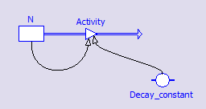

- Look at the model. Explain the elements of which the model is build.

- Open Coach 6 Activity Radioactive decay. In this activity the model is already prepared. Assume that the initial number of nuclei is 1000 and the each nucleus has a chance of 2% to decay in each time unit. Use these values in the model.

- Run your model. Describe the resulting graph of N(t).
- Compare the graph to the graph you sketched in activity 1. How do they different? How are they similar? Why are they similar?
- Investigate how the decay constant influences the rate of radioactive decay.
- Find out which function describes best the radioactive decay. How will you do this?

- Determine the time in which the number of nuclei halves.

- Radioactive decay can be expressed with the following formula:

where
λ is the decay constant, commonly measured in s^{–1} or min^{–1}.
N₀ is the initial number of nuclei.

The decay constant is characteristic for a given radioactive isotope, and can thus be used to identify the contents of a radioactive sample.

The radioactive decay is measured in terms of a characteristic time, the half-life. The half-life is the time required for half of the present nuclei to decay. In other words the half-life is the time needed for a sample of a radioactive material to become half as radioactive as it was originally.
A linear plot of the natural log of the decay rate versus time can be used to determine the half-life of an isotope.

if t= t_{1/2} then N=N₀/2 and
and half-life is

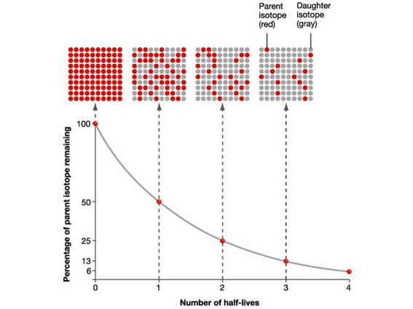

- In this activity you are going to measure the radioactivity of a source as a function of time.

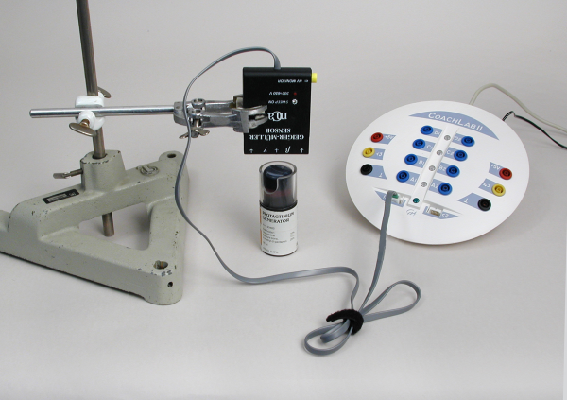
In your experiment you will use:
- An isotope generator (the Protactinium Pa-234m generator or Barium 137m generator),
- A detection device: a Geiger-Müller counter or a radiation sensor with a data-logger and software (Coach 6).

Follow all safety procedures for handling radioactive materials.
Follow any special instructions of use and safety included with your isotope generator.

- Record the radioactivity of your radioactive source.
Tips:
- To improve the quality of your data you can subtract the background radiation.
- When you use an isotope generator work quickly; the radioactive material begins to decay immediately.

- Determine the decay constant of the radioactive isotope used in your experiment.

- Calculate the half-life value. Repeat the measurement at least a few times, determine the average of the half-life values from all measurements and calculate the standard deviation.

- Compare the experimental half-life value with the theoretical half-life value.

- Modify your model from activity 2 to create a model of the radioactive decay of the radioactive isotope used in your experiment.

- Compare your model data with your experimental data. How well does your model fit to the experimental data?

