3. X-ray medical machine
- X-rays are a wonderful addition to the world of medicine. They make it possible to look inside a patient without any surgery. You will now have a closer look how an X-ray machine works.

Below you see a simple idea drawing of an X-ray machine. The heart of the X-ray machine is an X-ray source, the device where X-rays are produced. This device is shown in detail on the picture. Look at this picture and explain how the X-ray beam is generated?
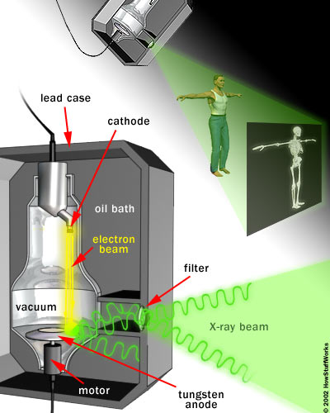
http://science.howstuffworks.com/x-ray2.htm

- Why do you think the tungsten anode needs to be rotated?

- Why do you think the X-ray source is placed in a lead case?

- Why do you think the tungsten anode needs to be rotated?

- Why do you think an oil bath surrounds the envelope?
- The heart of an X-ray machine is its X-ray source, which consists of a cathode and an anode placed inside a glass vacuum tube.

The cathode is a hot filament. When a current passes through the filament, it heats up and it begins to emit electrons. The positively charged anode, a flat disc made of tungsten, attracts the electrons across the tube. The voltage difference between the cathode and anode is extremely high. When electrons strike the anode X-ray, photons are emitted. Only about 1 per cent of the energy used is emitted as X-rays, the remaining energy is dissipated in the anode as heat. In most systems the anode is rotated so that the electrons strike only a small portion of the anode allowing the rest to cool. A cool oil bath surrounding the envelope also absorbs heat. A thick lead shield surrounds the entire mechanism. This keeps the X-rays from escaping in all directions. A small window in the shield lets some of the X-ray photons escape in a narrow beam. The beam passes through a series of filters on its way to the patient.

The photo below shows an exemplary X-ray machine.

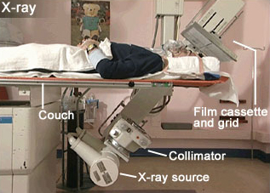
Besides the X-ray source, the machine consists of:
Collimator – allows altering the dimensions of the emerging X-ray beam. This helps to ensure that only the region of interest is exposed to the X-rays.

Couch - must be radio-translucent which means that it allows most of the X-rays through. Nonetheless there is some interaction between the couch and the X-rays which can be the cause of scattered radiation.

Film cassette and grid - as the X-rays pass through the patient, some will be scattered and will therefore not follow the expected line through the patient. If these reach the detector they will blur the image. A grid that is placed between the patient and the detector can remove some of this scattered radiation.
For detection analogue or digital imaging systems are used.
Analogy imaging systems use film or a combination of a film and fluorescent material (phosphor) to record the image. In the second solution the phosphor fluoresces and produces visible light, which is recorded by the film.
Digital imaging systems use a variety of methods to record the intensity for each pixel in the image. This can then be displayed on a screen or printed out on film.

- Find out in what types of medical examinations X-rays are used. The photo shows one of these.
- Explain how an X-ray machine may differ depending on the aim of the X-ray photos, which it makes.

http://science.hq.nasa.gov/kids/imagers/ems/xrays.html

