1. X the unknown

- Listen and watch the Science Channel's movie: Discovery of X-rays.
(Play via http://videos.howstuffworks.com/science-channel/29105-100-greatest-discoveries-discovery-of-x-rays-video.htm).
Have the following questions in mind:
- What experiment did W. Roentgen perform in 1895?
- What startled Roentgen during his experiment?
- What did he accidently discover?
- How did his discovery influence the world?

- The discovery of Wilhelm Roentgen precipitated one of the greatest medical advancements in human history. “In recognition of the extraordinary services he has rendered by the discovery of the remarkable rays …” he was the first man to receive the Nobel Prize in Physics in 1901.

What are these un-known X-rays?

- The image below shows the electromagnetic spectrum. Analyse the spectrum and explain what you think X-rays are?

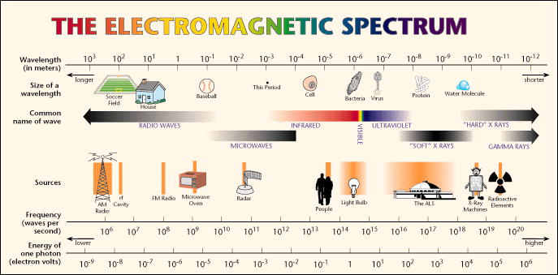

http://www.lbl.gov/MicroWorlds/ALSTool/EMSpec/EMSpec2.html

- X-rays are basically the same thing as visible light rays. Both are wavelike forms of electromagnetic energy carried by particles called photos. The difference between X-rays and visible light is the energy of the individual photons. This is also expressed as the wavelength of the rays. The energy of X-ray photons is much higher than the energy of light photons. The wavelength of X-rays lays between 0.1 and 10 nanometer.
Visible light photons and X-ray photons are both produced in similar way. …
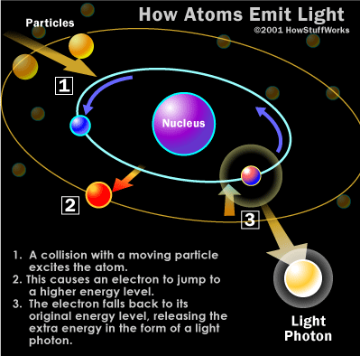
Electrons in an atom occupy different energy levels, or orbitals, around the atom's nucleus. When an electron drops to a lower orbital, it needs to release some energy - it releases the extra energy in the form of a photon. The energy level of the photon depends on how far the electron dropped between the orbitals.
When a photon collides with another atom, the atom may absorb the photon's energy by boosting an electron to a higher orbit. For this to happen, the energy level of the photon has to match the energy difference between the two electron positions. If not, the photon cannot shift electrons between orbitals.
http://science.howstuffworks.com/x-ray1.htm

The usual way of producing X-rays involves the use of an X-ray vacuum tube. An example of such atube is shown in the figure below. The heated filament (cathode) emits electrons, which are accelerated through a potential of more then 10 000 V. The electrons strike the anode and cause it to emit energy as X-ray photos.

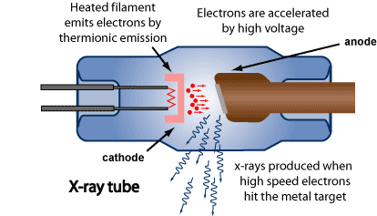
Origin: http://www.arpansa.gov.au/radiationprotection/basics/xrays.cfm
- Listen and watch the You Tube movie ‘How does an X-ray Tube Work’.
Play via http://www.youtube.com/watch?v=Bc0eOjWkxpU.

Find out the answers for the following questions:

- Explain what Bremsstrahlung is? Describe by which the interaction this radiation is caused.
- Describe a second interaction which lead to the production of X-rays?
- Sketch the exemplary X-ray spectrum as a plot of the number of photons against the photon energy.
- What happens to the spectrum when the potential energy between anode and cathode is increased?

1 = nanometer = 10⁻⁹ m

