5. Ultrasound imaging

- Ultrasound imaging is a popular technique used in medical imaging.
As you have learned the ultrasound B-scan shows a two-dimensional image, in other words a “slice” of a three-dimensional object (foetus, organs). This type of ultrasound image we all are familiar with. Two other, more advanced, types of ultrasound images are currently used in medicine, Doppler and 3D ultrasound images.
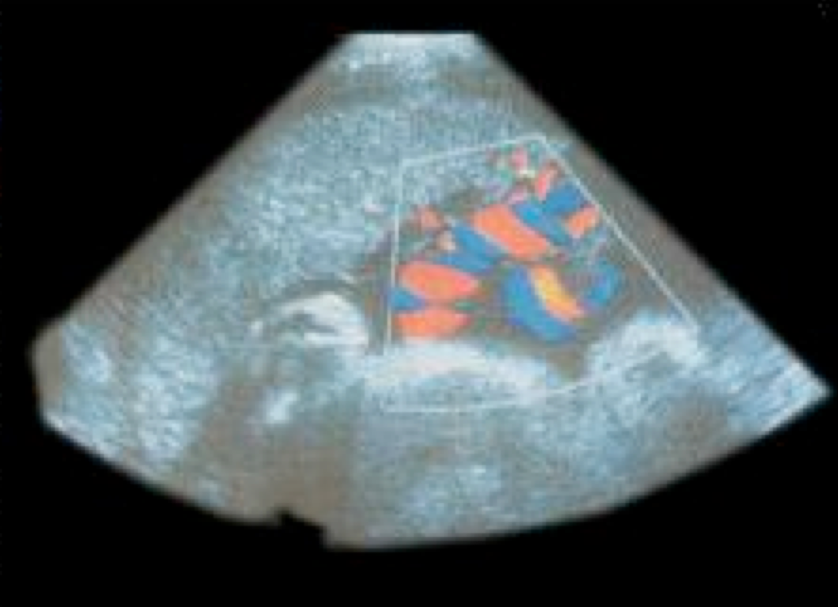

Doppler ultrasound scans allows imaging moving objects for example the blood flow through the heart (image shown on the left). Red colour on the image indicates the blood flow towards the transducer; blue colour indicates the blood flow away from the transducer.

Several two-dimensional images can be combined to form 3D images. This is done by specialized ultrasound machines equipped with a computer. An example of such a scan is shown on the left. The scan shows a 3D image of a 23-week foetus. This is a very new technology.

- Did you have an ultrasound scan yourself? What kind?

- What do you think; does ultrasound hurt?

- Do you think ultrasound is safe?

- Find out what are the advantages and disadvantages of ultrasound imaging in medicine.

Advantages | Disadvantages

- In a few days you will visit a place where patients undergo an ultrasound examination. During your visit you will have to learn how an ultrasound machine works, from which parts it is built and how an ultrasound examination is performed. You will interview a person, a sonographer, who operates a ultrasound machine and takes ultrasound scans.
Write down the questions which you want to ask during this interview.

- Based on the information you have collected during your interview, create a leaflet for patients having an ultrasound examination.

