4. Make a B-scan

- Usually a doctor would prefer at least a two-dimensional picture of a body's internal structure, rather than the simple one-dimensional picture of reflection interface locations along a line that the A-scan gives.
Is it possible to create such two-dimensional image?

- Start the Flash simulation Ultrasound Imaging without Object.

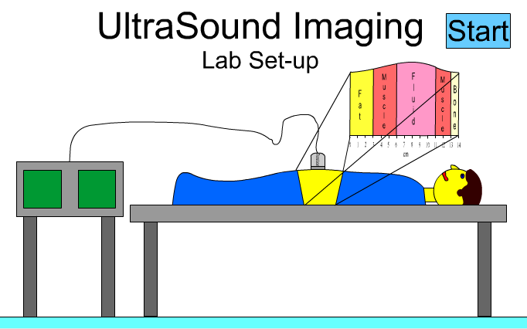

In the simulation, the ultrasound transducer produces an ultrasound pulse, which is transmitted into a patient’s body.

- Click the Start button and observe what happens to the ultrasound pulse. Explain the behaviour of the ultrasound pulse. You can repeat the simulation by clicking Reset and Start again.

- During the animation two different ultrasound scans are simultaneously created.
The A-scan (shown on the left) and B-scan scan (shown on the right). Compare the two scans, how do they differ?

- Look at the B-scan, how do you think it is created?

- The B-scan stands for brightness scan. The amplitude of an echo from the A-scan is converted into the brightness of a point on a display. The larger the amplitude of the echo, the brighter the spot is displayed.

- Look at the B-scan in your simulation. Do you see difference in brightness? Explain.

In the B-scan data is presented in a more visual format. By moving the transducer, a two-dimensional image can be constructed.
- The Ultrasound Imaging without Object can be used to show how the B-scan information can be built up into a two-dimensional image.
Notice that the transducer can be moved along and data can be collected in different places of the body. Create ta wo-dimensional scan.
(Tip: First click Start to collect data. Click Reset en move the transducer to another location; click the Start again to collected data in the new place. Repeat! )
- Draw below your resulting B-scan.
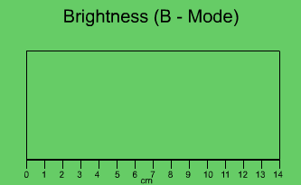

- Start the Flash simulation Ultrasound Imaging with Object. Create a body scan and draw it below.
- Explain how you can see on your scan that there is an extra object inside a body.

- The B-scan image shows a two-dimensional picture of interfaces within the body. We would expect that interfaces between the same two tissue types should lead to the same brightness on the image display. Unfortunately, this is not the case.

- What happens to the intensity of sound waves as they travel through a medium? Think about how well you can hear a normal conversation when you are standing next to the people talking and when you are 10, 20, 30, or more feet away. What will happen to the brightness of the echoes for interfaces that are farther away from the transducer?

- Ultrasonic machine corrects the ultrasound image for this problem. An example of B-scan is shown on the image below. The image shows a growing fetus inside a mother. Look at the picture and indicate the baby head, neck, torso. Can you recognize other parts of the baby?

