3. Make an A-scan

- The reflection of ultrasound pulses by structures within a human body is the interaction that makes possible to create the ultrasound image. In this activity you will learn more about the way ultrasound images are created.
There are several kinds of ultrasound imaging systems. The earliest device, which forms the basis for later systems, is called the A-scan. The “A” stands for amplitude (of an echo).

- Let us get an idea of how the A-scan works by considering the echo experiment. You may have done this experiment in a previous lesson.

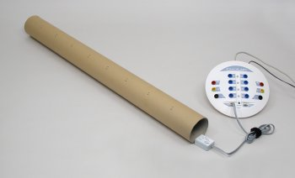
A hollow cartoon tube is closed at one end. A sound sensor connected to a data-logger and computer, is placed at the opening of the tube. The sensor records the initial sound made by snapping fingers and the echo after the sound pulse travels the length of the tube and back. The length of the tube used in the experiment is 0.9 m. (You may have done this experiment in the previous lesson).
The figure below shows the recorded sound. The vertical axis shows the amplitude of the sound signal and the horizontal axis shows the time.
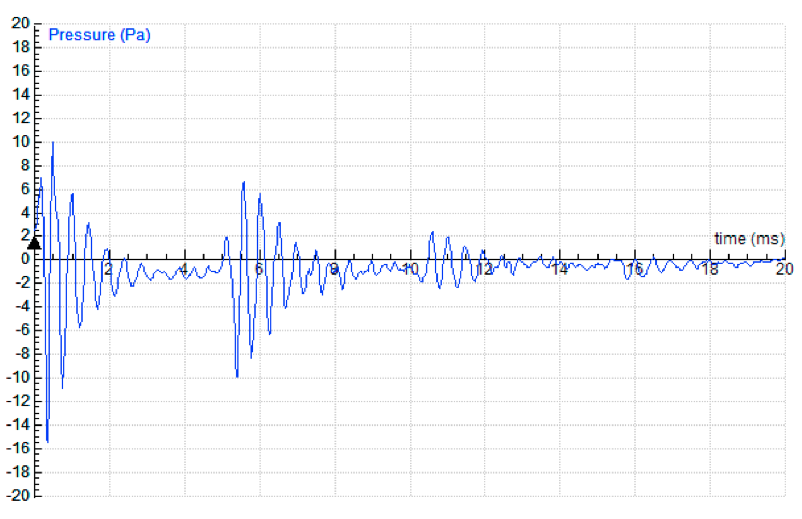
- How would the graph change if a 50% longer tube (1.35 m long) would be used instead?

- Suppose the tube had been filled with an additional barrier, at 0.45 m from the end. If the barrier allowed transmission of sound, as well as reflection, how might the graph look when the echo experiment is done?

- What change could you make to this graph so that it shows the object position encountered by the sound pulse?

- The basic idea behind the A-scan is to use timing data of sound echoes to calculate the distance of objects from the ultrasound transducer.
By assuming a constant speed of sound, we can calculate the distance to an object by using the time between the initial sound pulse (the finger snap in this case) and its echo.

- Why can we assume that the speed of sound is constant?
- If Δt is the time between the moment of the initial sound and the moment of the detection of its echo, and v is the speed of sound, then the distance, d, to the object is (write down equation):

- The equation written above can be used to convert the amplitude versus time graph to amplitude versus distance (position) graph. An A-scan instrument would do this calculation automatically.
An A-scan gives a one-dimensional picture of what is in front of the transducer. It tells the observer where there are reflection interfaces along a line drawn out from the transducer.

- Draw the A-scan graph based on the graph from activity 1.

- Suppose you must design instrumentation for making an A-scan image of the eye.

- What would you assume to be the speed of sound in the eye? Explain.

- Obtain some anatomical information about the eye and estimate how much time the A-scan instrument must accommodate (wait for an echo) to obtain an image of the various reflection interfaces inside the eye?

- In the picture below you see the five primary amplitude spikes in A-scan ultrasound. Look at the picture and find out which parts of the eye generate these spikes.

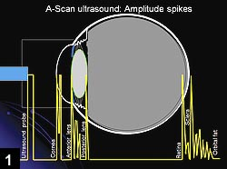

Image: Uday Devgan (http://www.osnsupersite.com/
view.aspx?rid=27153)

- The photo below shows the way a doctor performs an ultrasound A-scan of the eye. Notice the patient is parallel to the floor and is looking to the ceiling, which results in a high-quality A-scan. Can you explain Do you know why?
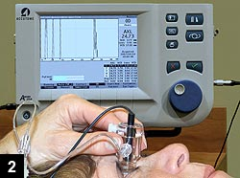

Image: O’Connor J, Accutome
(http://www.osnsupersite.com/
view.aspx?rid=27153)

