Experiment D: Differentiation between Chitosan and Chitin

|  |
| --- |
| **Source:** |

According to Bader, Birkholz, in: Chitin Handbook, R.A.A. Muzzarelli and M.G. Peter, eds., European Chitin Society. 1997. ISBN 88-86889-01-1

Finger, H.: Chitin und Chitosan – Neue Rohstoffe auf dem Weg zur industriellen Nutzung, WS 1999/2000, Marburg,

|  |
| --- |
| **Equipment:** |

2 watch glasses, 2 Pasteur pipettes.

|  |
| --- |
| **Reagents and materials:** |

|  |  |  |  |
| --- | --- | --- | --- |
| **Reagents and materials** | **H-Phrases** | **P-Phrases** | **Danger symbol** |
| Chitin |  |  |  |
| Chitosan |  |  |  |
| I2/Kl-solution (0.2 g I2 in 100 ml Kl-solution (w = 5%)) |  |  |  |
| Sulphuric acid (w = 1%) |  |  |  |

|  |
| --- |
| **Procedure:** |

**j0346317[1] Do not forget safety glasses and lab coat! Work at the extractor hood!**

Some flakes of chitin or chitosan are put onto a watch glass. 2-3 drops of I2/KI solution are added and the mixtures are acidified with 2-3 drops of sulphuric acid.

 Chitin and chitosan treated are added to the waste jar for solids.

|  |
| --- |
| **Observation:** |

After addition of I2/KI solution, the chitosan changes color to dark brown and the solution becomes colorless. On addition of sulphuric acid, the dark brown color turns dark purple.

On the opposite side, chitin remains unchanged on addition of iodine solution, which retains its brownish-yellow color. Also, the acidification with sulphuric acid has no consequence.

|  |
| --- |
| **Analysis:** |

A definite analysis of the experiment does not exist, but a suggestion for an analysis, which shall be presented here: Like the reaction of iodine with starch, chitosan is meant to establish a host-guest complex. To make this clear, the complex is illustrated below. The starch exists in a helix-formed conformation, which creates void spaces, in which the poly-iodine chains are inserted to. This is meant to happen similarly with chitosan. Chitin, on the other hand, is to be sterically inhibited in that regard (residues of acetylamine). However, a helix-formed order of the monomers, which is given with starch by α-1,4-links, is a requirement for this. In chitosan, however, the monomers are β-1,4-linked (according to Finger).

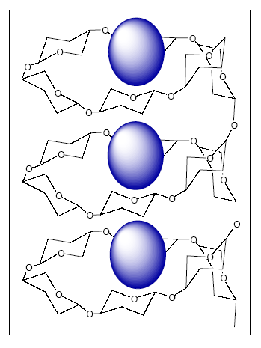

Fig.: Iodine-Starch host-guest complex

|  |
| --- |
| **Source of errors:** |

|  |
| --- |
| **Links:** |