Activity 3.8: Ecological view on textile care

Worksheet 12: The influence of temperature on wash performance²⁵

Imagine you have a cocoa stain on your white T-shirt! Is it true that the higher the wash temperature is, the more easily the stain can be removed? To find out, you will be given cocoa-stained cotton cloths to wash at different temperatures.

Tasks
- Plan an experiment, with which you can test wash performance at different temperatures. Make a sketch of the experiment first, and then briefly write down what you are going to do.
- Carry out your experiment and record the wash result.
- At which temperatures did you obtain the best wash result? Why is this?
- Investigate how much energy you could save by washing at 30°C or 40°C instead of 60°C. Calculate the saving in electricity costs. Which other electrical appliances could you run with the saved energy?

²⁵ Worksheet taken from: http://www.henkel.com/com/content_data/106612_4.8.2_Sustainable_washing_for_a_clean_environment_Chemistry_for_Advanced.pdf

Worksheet 13: Improving wash performance by adding stain remover²⁶

The chosen wash temperature is one of the factors that influence how good the wash performance is. In this experiment you will now investigate how the addition of stain remover affects the wash performance. To do this you will be given cocoa-stained cotton cloths, which you will wash with laundry detergent, stain remover and a combination of laundry detergent and stain remover.
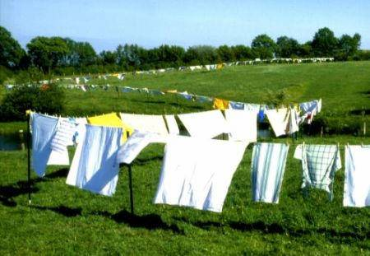

Tasks
- Plan a series of experiments with which you can investigate the effect of stain remover on wash performance. Make a sketch of the experiment first, and then briefly write down what you are going to do.
- Carry out your experiment and record the wash result.
- With which experiment did you obtain the best wash result? Why is this?

²⁶ Worksheet taken from: http://www.henkel.com/com/content_data/106612_4.8.2_Sustainable_washing_for_a_clean_environment_Chemistry_for_Advanced.pdf

Worksheet 14: The effect of laundry detergent dosage and water hardness on wash performance²⁷

You have probably seen the advice shown below on a packet of laundry detergent at home:
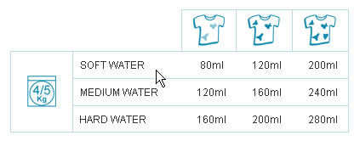

This shows the recommended dosage of laundry detergent for different degrees of soiling and water hardness. The experiment investigates the effect of the detergent dosage and the hardness of the water on the wash performance. This is done by washing pieces of cocoa-stained cloth using different dosages of laundry detergent.

Tasks
- Plan a series of experiments with which you can investigate the effect of the laundry detergent dosage and the hardness of the water on the wash performance. Make a sketch of the experiment first, and then briefly write down what you are going to do.
- Carry out your experiment and record the wash result.
- With which dosage did you obtain the best wash result? Why is this? Take the hardness of the water into account.
(Note: You can find an overview of water hardness on the Internet, e.g. by looking up the region’s waterworks.)

²⁷ Worksheet taken from: http://www.henkel.com/com/content_data/106612_4.8.2_Sustainable_washing_for_a_clean_environment_Chemistry_for_Advanced.pdf

Worksheet 15: The influence of laundry detergents on the growth of cress plants²⁸

Wastewater from households (for example from the washing machine) is thoroughly cleaned in sewage treatment plants so that it can be discharged into surface water. What would happen if we discharged our wastewater into the environment without subjecting it to any sort of treatment beforehand? This experiment shows the influence of a laundry detergent on the growth of cress plants. The wash water represents the wastewater, and the cress plants represent the environment.

Tasks
- Devise a series of experiments with which you can investigate the effect of the laundry detergent on the growth of cress plants. Use different concentrations of the laundry detergent. Make a sketch of the experiment first, and then briefly write down what you are going to do.
- Carry out your experiment and record your observations. How did the cress change under the influence of the laundry detergent?
- Plot your results on a graph.

²⁸ Worksheet taken from: http://www.henkel.com/com/content_data/106612_4.8.2_Sustainable_washing_for_a_clean_environment_Chemistry_for_Advanced.pdf

Worksheet 16: Biodegradability of surfactants – Part 1²⁹

Each year, about 250,000 metric tons of surfactants are used in households, trade and industry in the Federal Republic of Germany. Most of them – about 64 percent – are ingredients of laundry detergents and household cleaners. They are also used in cosmetics and pharmaceuticals, textile and leather auxiliaries and in numerous other sectors. Anionic surfactants are the most widely used (136,000 metric tons each year), followed by the nonionic surfactants (approximately 97,000 metric tons).
The surfactants used in households, e.g. to wash laundry, enter the drains unchanged in the wash liquid. High concentrations of surfactants are toxic to many aquatic life forms (e.g. fish and algae). For reasons of environmental compatibility, it is therefore very important that these surfactants are rapidly removed from the environment, e.g. by undergoing biodegradation.
There are two stages of surfactant biodegradation: primary and ultimate.
When primary biodegradation occurs, the basic chemical structure of the surfactants remains largely unchanged, but they lose their characteristic ability to dislodge dirt. They also become less toxic to organisms that live in water, and form less foam.
As biodegradation proceeds, the surfactants are broken down into ever smaller and simpler units. These changes are caused by the metabolic processes that take place in microorganisms that use organic substances as food. Finally the surfactants are converted into mineralization products such as carbon dioxide (CO₂), water (H₂O) and salts, together with biomass (bacterial cell material). The biomass is formed from small C-H units, and its formation is the reason why, strictly speaking, substances never undergo 100% ultimate biodegradation.
In 1973, Europe’s first piece of legislation regulating the ingredients of laundry detergents and household cleaners came into force. This was the Detergent Directive. It stipulated that anionic and nonionic surfactants in laundry detergents and household cleaners would have to have a primary biodegradability of at least 80%. During the following years, however, the consumption of laundry detergents and household cleaners continued to increase and the required primary biodegradability proved to be no longer adequate. The new so called EU Detergent Regulation of 2004 therefore stipulated that all washing-active surfactants in laundry detergents and household cleaners must be ultimately biodegradable.
Tests of primary biodegradability include the OECD Confirmatory Test and the OECD Screening Test. Tests of the ultimate biodegradability of organic compounds include the Closed Bottle Test (OECD 301 D) and the Coupled Units Test (OECD 303 A).
Tasks
- Explain the difference between primary and ultimate biodegradation of surfactants. Why is it not possible to achieve 100% ultimate biodegradation?
- In the late 1950s, mountains of foam could be observed on surface waters. These were caused by the surfactants in the laundry detergents that were in use at that time. Explain how foam came to be formed on surface waters.
- Search the Internet for information about OECD test methods. Briefly describe one test for primary biodegradation and one for ultimate biodegradation.

²⁹ Worksheet taken from:
http://www.henkel.com/com/content_data/106612_4.8.2_Sustainable_washing_for_a_clean_environment_Chemistry_for_Advanced.pdf

Worksheet 17: Biodegradability of surfactants – Part 2³⁰

Most of the ingredients of laundry detergents pass into sewage treatment plants with the wastewater. There they either undergo biodegradation or are removed by other processes before the cleaned wastewater is discharged into surface waters. If small amounts of ingredients, e.g. surfactants, do manage to enter the environment, nature is not completely defenseless, as some natural organisms are able to break down surfactants and other chemicals. This experiment shows what happens when small amounts of laundry detergents enter a river or lake.

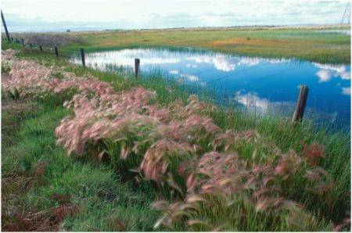

Tasks
- Plan an experiment, with which you can investigate the biodegradability of surfactants in rivers and lakes. Make a sketch of the experiment first, and then briefly write down what you are going to do.
- Carry out your experiment and record your observations. Find explanations for what you observed.

³⁰ Worksheet taken from:
http://www.henkel.com/com/content_data/106612_4.8.2_Sustainable_washing_for_a_clean_environment_Chemistry_for_Advanced.pdf

Worksheet 18: Biodegradability of surfactants – Part 3³¹

Since the mid-1950s, modern surfactants were used in large quantities in laundry detergents and household cleaners. Tetrapropylenebenzene sulfonate (TPS) was the first poorly biodegradable surfactant to be used. A visible sign of this was the mountains of foam on watercourses (Fig. 1).
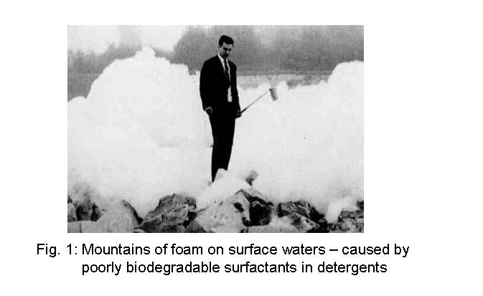

The detergent industry responded by starting to develop and introduce readily biodegradable surfactants. Between 1961 and 1964, TPS was gradually replaced in the West Germany by linear alkylbenzene sulfonates (LAS). Moreover, the Henkel company measured the surfactant load in the river Rhine at two-weekly intervals. The results were made available to scientists, politicians and supervisory bodies, and were published annually. In the 1970s, the municipal sewage plants were also upgraded.

Tasks
Material 5 shows an overview of laundry detergent consumption in Germany from 1960 onward, and an overview of the surfactant loads in the river Rhine near Düsseldorf from 1958 to 2007.
- Describe the course of the two graphs.
- How can the graph of the surfactant load over time be explained in relation to the use of surfactants in laundry detergents?

³¹ Worksheet and relating Material 5 are taken from:
http://www.henkel.com/com/content_data/106612_4.8.2_Sustainable_washing_for_a_clean_environment_Chemistry_for_Advanced.pdf

Material 5
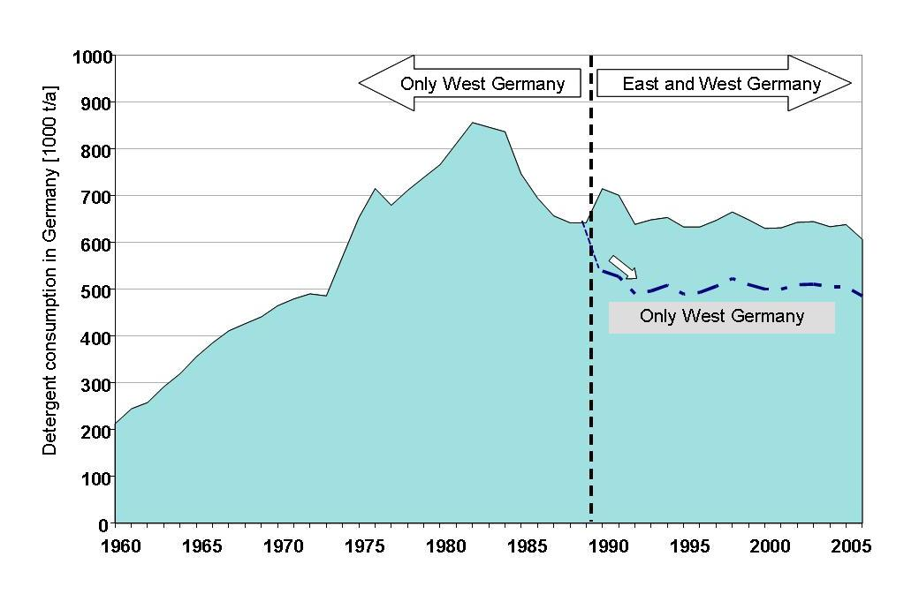

Fig. 1: Laundry detergent consumption in Germany
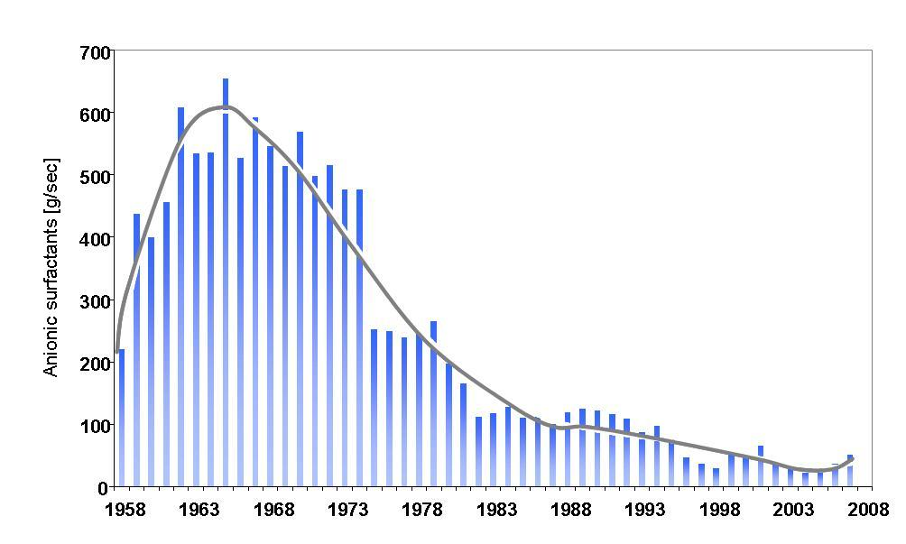

Fig. 2: Surfactant loads (median values) in the river Rhine near Düsseldorf (1958 – 2007)

Worksheet 19: Biodegradability of surfactants – Part 4³²

The surfactant tetrapropylenebenzene sulfonate (TPS), which is poorly biodegradable, was phased out in West Germany between 1961 and 1964, and was replaced by surfactants known as linear alkylbenzene sulfonates (LAS).

The following diagrams show the structural formulas of TPS and a LAS:

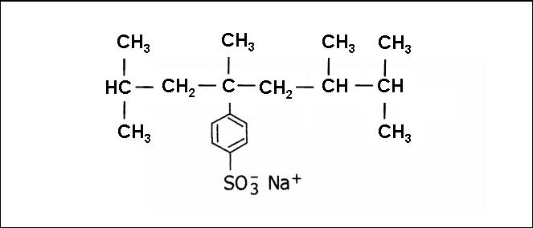

Figure 1: Tetrapropylenebenzene sulfonate (TPS)

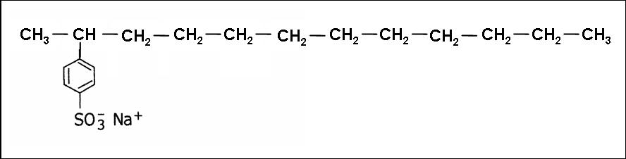

Figure 2: 2-Dodecylbenzene sulfonate (a LAS)
Task
What might the reason be for the poorer biodegradability of TPS relative to LAS?
Remember that the surfactants are broken down in surface waters by microorganisms.

³² Worksheet taken from:
http://www.henkel.com/com/content_data/106612_4.8.2_Sustainable_washing_for_a_clean_environment_Chemistry_for_Advanced.pdf

Worksheet 20: Ecological impacts of the phosphates previously used in laundry detergents³³

Phosphates are all around us in the natural world. The metabolism of every organism, including humans, needs compounds that contain phosphate groups. If excessive amounts of phosphate enter lakes, however, as they did in the days when detergents contained phosphates, a surplus of plant nutrients can accumulate in the lake. This stimulates the growth of algae, which constitute most of the biomass in the water. The organisms that live on algae can therefore also multiply, and there is a knock-on effect at the next highest levels of the food chain. More algae means more photosynthetic activity, releasing oxygen, so that a surplus of oxygen accumulates in the upper layers of the lake. And because there is more biomass, more organisms die. The dead biomass sinks to the bottom of the lake, where microorganisms break it down aerobically, i.e. consuming oxygen as they do so. This results in a shortage of oxygen in the deeper water layers. In the absence of oxygen, anaerobic bacteria multiply, releasing toxic metabolic products as they do so. These toxic products cause many forms of life in the lake to die. The oxygen-depleted lake can no longer be used as a source of drinking water. Over-enrichment of aquatic systems with plant nutrients (C, N, P) is referred to as eutrophication.

Task
Add captions to the following diagram to illustrate the process of eutrophication. Use the following terms: Phosphates, anaerobic digested sludge, strong plant growth, oxygen-rich, nutrient-rich, oxygen-depleted, nutrient-depleted

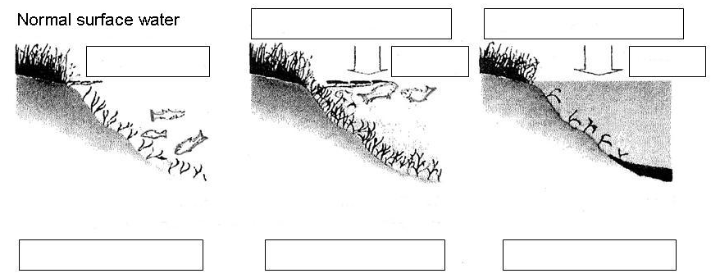

The phosphate content of Lake Constance – Germany’s biggest inland body of water – has been studied for many years. The knowledge gained can be applied to other bodies of water such as the North Sea and the Baltic. The diagram below shows the phosphate concentration in Lake Constance from 1950 to 2004.
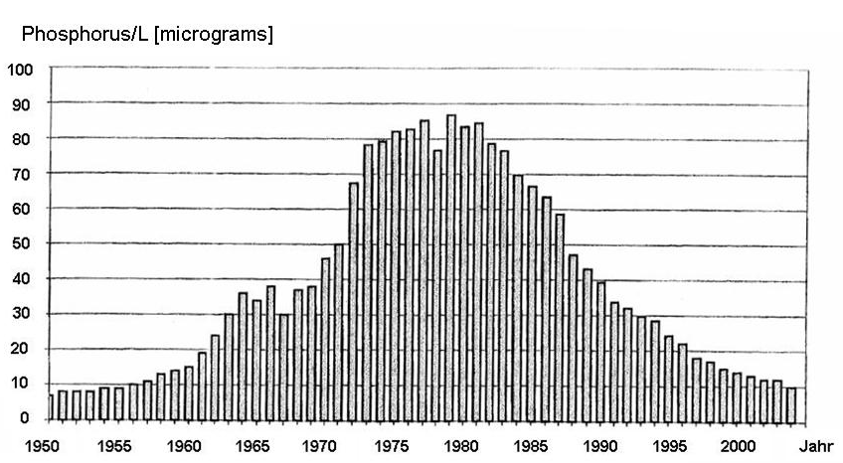

Fig. 1: Phosphate concentration in Lake Constance from 1950 to 2004

Task
Explain the curve of the phosphate concentration in Lake Constance. Draw on Materials 6, 7 and 8 in your explanation.
³³ Worksheet and relating Materials 6-8 are taken from:
http://www.henkel.com/com/content_data/106612_4.8.2_Sustainable_washing_for_a_clean_environment_Chemistry_for_Advanced.pdf

Material 6

Population of the former West Germany from 1950 to 2006:

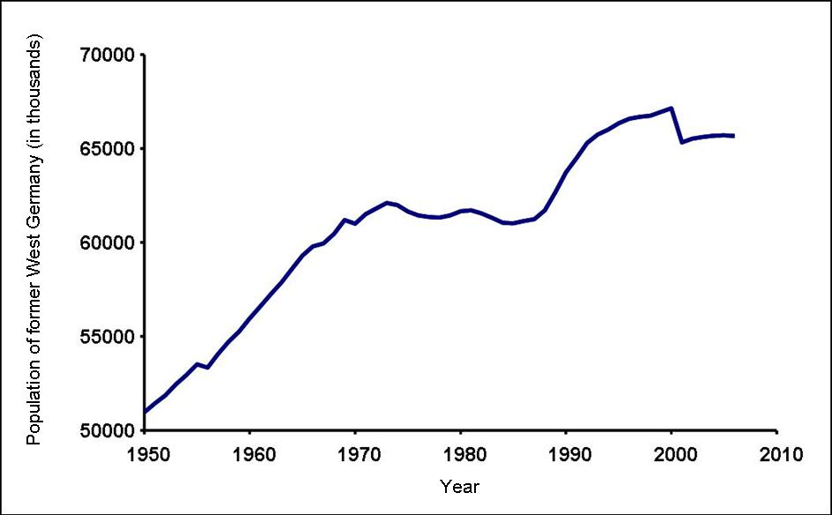

Source: German Federal Statistical Office (www.destatis.de).

Material 7

The history of phosphate-free laundry detergents

Year | Event
From 1930 | Phosphates present in laundry detergents
1950 – 1959 | New raw materials such as the water softener sodium tripolyphosphate used in laundry detergents.
1966 | Phosphates in laundry detergents are recognized as playing a key role in the eutrophication of lakes. The search for phosphate substitutes starts.
From 1970 | Increasing emphasis on biochemical wastewater treatment
1973 | Filing of patent application for phosphate substitute Zeolite A (brand name Sasil®).
1975 | Environmental safety assessment of phosphate substitute Zeolite A in laundry detergents
1977 | Successful trial of the first low-phosphate laundry detergent containing Zeolite A.
1983 | The first completely phosphate-free laundry detergent is launched on the market. In the following years, phosphate-free laundry detergents become established in Western Europe.
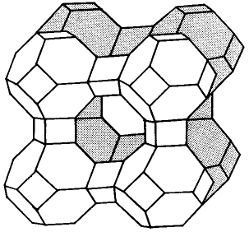

Figure: Sasil® crystal

Material 8
The central sewage treatment plant of the city of Constance is designed for a population equivalent of 215,000 and is the largest on Lake Constance. Each day, up to 40 million liters of wastewater are treated. This is equivalent to the content of about 2000 road tankers. The plant’s precipitant and dispensing unit is shown in the diagram. (Source: Entsorgungsbetriebe Stadt Konstanz, www.konstanz.de/imperia/md/content/ebk/89.pdf)
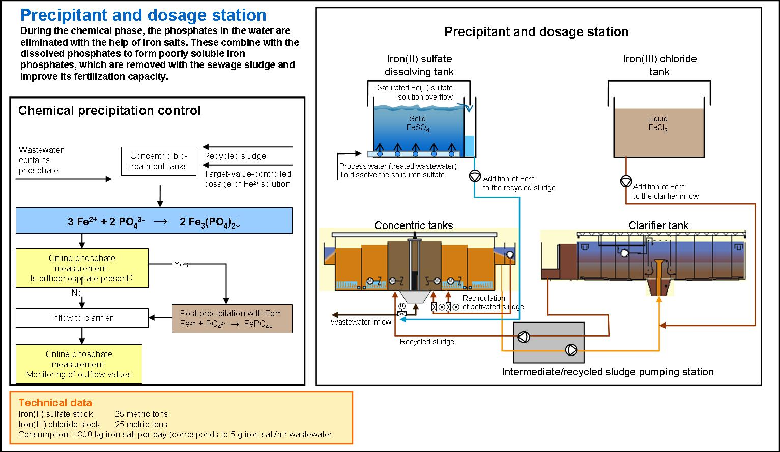

Worksheet 21: Sustainability in the laundry detergent industry³⁴

Climate change and the limited availability of water and energy are two major themes that affect us all. For this reason, many companies have undertaken to embrace the principles of sustainable development and social responsibility in the conduct of their business.
Many revolutionary advances of days gone by, such as the “self-acting detergent” and phosphate-free products are now established in our everyday lives. However, laundry detergent developers cannot afford to bask in the glow of yesterday’s successes – today, ideas for improved and new products are in continuous demand. Responsible companies know that sustainability has three dimensions, all of which must be taken into account in their business practices:
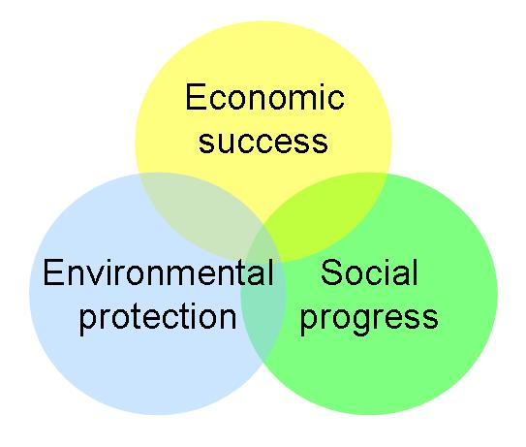

Tasks
- In Henkel’s Sustainability Report 2007, you can find examples of innovations in the laundry detergent industry from the beginnings down to the present day. Read pages 3–7 of the Sustainability Report. You can find the report on the Internet at:
http://www.henkel.com/cps/rde/xchg/henkel_com/hs.xsl/12152_COE_HTML.htm
- Find examples of innovations and assign them to the above dimensions.
- What are the advantages of these innovations?
³⁴ Worksheet taken from:
http://www.henkel.com/com/content_data/106612_4.8.2_Sustainable_washing_for_a_clean_environment_Chemistry_for_Advanced.pdf

