Worksheet 1.1 What are ‘sources’ of light?

1. Light is all around us. It allows us to see, but where does light come from?
Have a look around your classroom and list five objects that you can see:

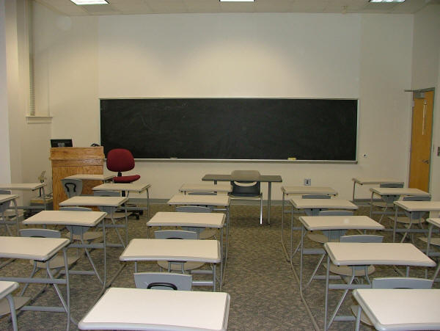

2. Are any of these five objects a source of light?

3. Are a candle and torch sources of light? Explain.
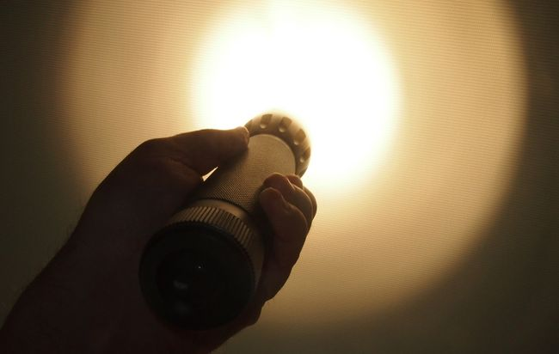
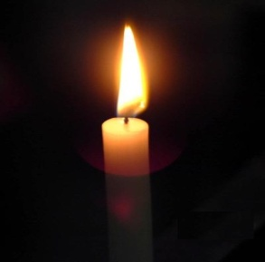

4. What are the differences between the candle and torch in terms of their physical properties?

5. In science we attempt to characterise objects in our universe and group them together according to common properties. In the table below, write down four properties you think light sources have and then list five light sources.

Source of light | Property 1  ________ | Property 2  ________ | Property 3  ________ | Property 4  ________
1.
2.
3.
4.
5.

6. Does each source of light have the same properties?

7. Do the properties you have listed only apply to sources of light or do they apply to objects that are not sources of light as well?

8. Why can you see objects that are not sources of light?

