Activity 1.2.9 Tensile strength of plastic materials

Materials:
Set of weights, different kinds of plastic, cotton, metal and wood

Procedure:
Before the experiment, formulate your hypotheses about tensile strength of plastic materials and natural substances. Look at the above-mentioned materials and discuss their firmness. Carry out the following experiment afterwards:
Hang different weights on a particular kind of plastic, cotton, metal and wood and note the length of their stretch. Write your findings into the table:

Findings:
1. Complete the table:

Plastic | WEIGHT
PVC
Polyethylene

Polypropylene

Polystyrene

Natural substances | WEIGHT
Cotton

Metal

Wood

2. Do all plastic materials have the same tensile strength? If no, compare the firmness and resistance of the above materials.
..............................................................................................................................................................................................................................................................................................................

Homework:
Look up on the Internet information about plastic materials with outstanding mechanical properties and read about their use in practice.

Conclusion:
Complete the table based on the acquired knowledge:

Plastic | FOUND PROPERTIES | USE IN PRACTICE
PVC
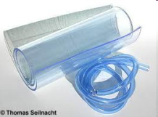
Polyethylene
Polypropylene

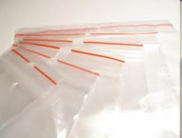
Polystyrene
