Activity 1.2.6 Electrical conductivity of plastic materials

a) Comparing electrical conductivity of plastic materials with that of other materials
Materials:
Source of electricity, electric bulb, different kinds of plastic, cotton, metal and wood

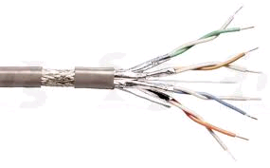
Procedure:
In groups discuss electrical conductivity of plastic materials and that of natural substances (cotton, wood, metal). Write down your hypotheses and compare them with the results of the experiment afterwards.

Hypotheses:
.......................................................................................................................................................
.......................................................................................................................................................

Carry out the following experiment:
Prepare a simple electrical circuit and connect into it a particular kind of plastic, cotton , metal and wood, respectively.
Write your findings into the table

Findings:

Tab. Conductivity of plastic materials
Plastic | Conductivity | Natural substances | Conductivity
PVC |  | Cotton
Polyethylene |  | Wood
Polypropylene |  | Metal
Polystyrene

What could you say about electrical conductivity of plastic materials?
.......................................................................................................................................................

Homework:
Look up on the Internet information about using plastic materials as electrical conductors / insulators.
..............................................................................................................................................................................................................................................................................................................
..............................................................................................................................................................................................................................................................................................................
..............................................................................................................................................................................................................................................................................................................

b) Static electricity and plastic materials

Materials:
Plastic spoon, cotton cloth, polystyrene balls

Procedure:
In groups discuss and tackle the following problem: When Ann came home, she took off her nylon stockings. When she then touched a metallic door handle, she screamed and jumped out of horror.
What happened to Ann? What is the substance of the phenomenon?
What caused the electric shock?

Hypotheses:
....................................................................................................................................................
....................................................................................................................................................
Try to simulate the situation using a plastic bar, cotton cloth and polystyrene balls. Write down the test procedure and findings.

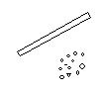
Procedure:
plastic bar

PS

.................................................................
.................................................................
.................................................................
.................................................................
.................................................................

Findings:
....................................................................................................................................................
..................................................................................................................................................

