3.3 Traces in the snow or mud.
Besides primary properties that can be directly measured there are also related clues hat follow from these properties. For instance when a student has a length of 1.50 m, it seems impossible that he or she can reach a shelf that is 2.10 m high (without help). Whereas a student with a length of 1.90 m should be able to reach this (stretching the arm).
Another example is the distance between your footprints. It seems reasonable to expect that the footprints of a taller person are farther apart than those of a smaller person. So the distance between the footprints can give a clue about the length of a suspect. It might as well be possible to decide, based on the footprints, if a person was running or walking.

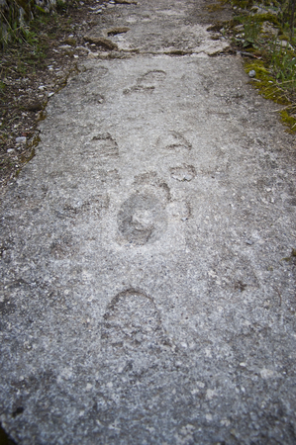
- Without doing any research or searching in literature, what do you think is the distance between two steps for a person with a length of 1.75 m?
- Measure the distance you cover when you walk normally a few steps (for instance ten meter).
- Calculate the distance you cover with one step. Explain how you did it.
- Put the results for the whole class in a diagram. Show step distance as a function of the body length. Make two different graphs, one for the boys and one for the girls.
- Find out in literature what is known about this so called ‘stride length’
- Discuss the results of your measurement and the literature research. Do they match?

On a crime scene, footprints in the mud (or in the snow) are 70 cm apart from each other. These traces are from the same shoe and they seem to belong to the suspect.
- What might be the length of the suspect (give a reasonable estimation)?

