3.1 Properties of human beings, properties of a suspect
In crime scenes, the traces and witnesses lead to a description of the suspect. The more details there are in a description, the higher the chance to find the criminal. A lot of descriptions start with simple and easily to recognize properties like length, gender and hair color. In this part we are going to measure and analyze a couple of properties from the students in your classroom. Some of these properties can be directly measured, other properties need to be deduced from other measurements (for instance step distance is related to the length of a person).

- Make a list of ten properties that can be easily be determined for the students in your class. For example: eye color, length, hair color, gender, weight, if you are left handed or right handed, shoe size, etcetera.
- Discuss how easy it is to change these properties as a person. That is: can a criminal disguise himself by changing this property.
- Make a table of these properties and fill in the data for each student in the group.

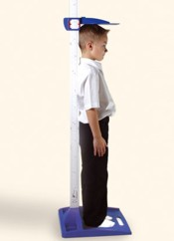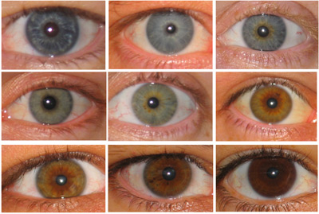

- Now it should be possible to answer the following questions:
  - How many male students do you have in your class?
  - What are the chances that a student from your class has brown eyes?
  - How many students are longer than 1.65 m?
  - How many students are shorter than 1.55 m?

