2.2 Crime solving game
In the Glasgow Science Centre, the mascot Birdbot has been kidnapped. This is a serious crime that needs to be solved. Hopefully you can help to solve this crime. Play the game and find out if you are a good detective.

You can find this game on: http://www.glasgowsciencecentre.org/glasgowscienceinvestigation.aspx
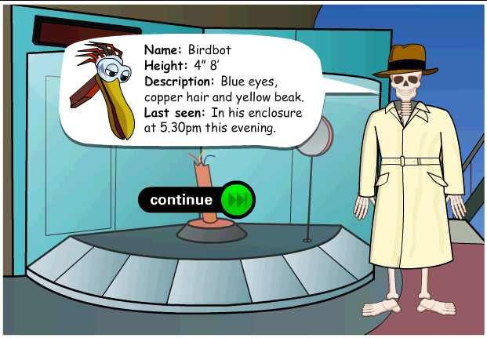
Detective Bones at the crime scene, asking for your help.
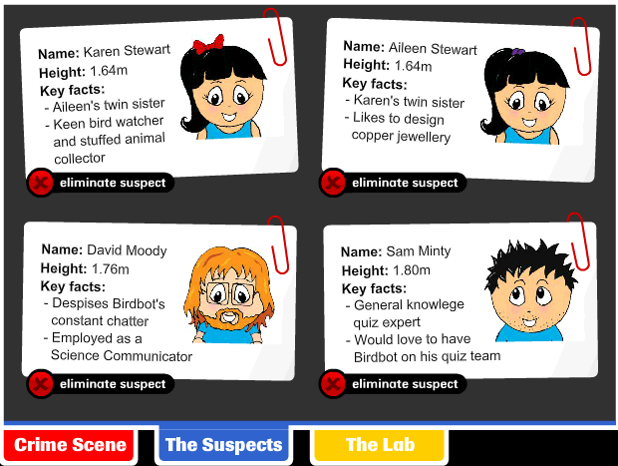

The four suspects to this crime.

In the crime in this case, as in a lot of other crimes, you use elimination to find the criminal.
- Explain what is meant with elimination.

In the game, you find different types of evidence
- The clues presented in this game, do they match the clues you advised in the previous activity? (write down which clues are used in this game that you yourself did not mentioned before)?

- Play the game and write down which clues eliminate which person.
- How long did it take you to solve the crime?
- Did everybody in the class accuse the same suspect?

