1.5 Identify the criminal
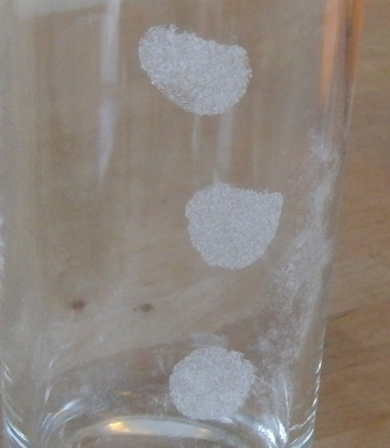
For this part, you work in a group with four students. One of you will take a glass in her or his hand thus leaving a finger print. You give the glass to your teacher (make sure to leave no other marks) and the teacher will give the glass to another group. You will get another glass from the teacher with a finger print from a student form another group.

- Leave a clear finger print from one of your group on the glass given to your group
- Give this glass and the finger print files from every member of the group to your teacher
You will get a glass touched by someone from the other group and the finger print files from the members of this group.
- Identify the person from the other group who touched the glass. Use your favorite method to take these fingerprints.
- Write a report on how you identified the criminal and how sure you are about your findings.

