1.4 Calculations on the ballpoint case
In the former activity, a lot of experiments were possible to simulate the ballpoint case.

One way to simulate this is to use mandarins and pens. In this activity we discuss the results of an experiment with these items.
- What are the similarities and what are the differences between model and reality in this experiment?
- What are the similarities and what are the differences between your model (previous activity) and this mandarin model?

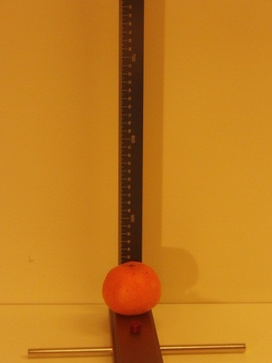 | 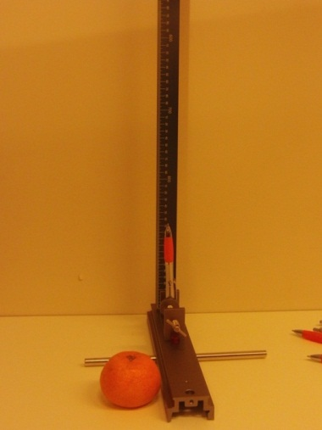 | 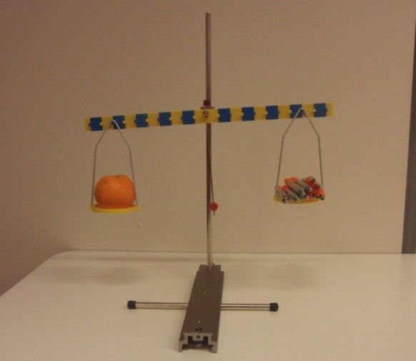
A mandarin weighs just about as much as nine pens. In a certain attempt of this experiment, a student drops a mandarin from exactly 100 cm on the pen and finds out that the pen penetrates the mandarin for 5.0 cm.
- Calculate the speed that the mandarin had just before making contact with the pen.
- Calculate the average force between mandarin and ballpoint in this collision.

To simulate the murder scenario the experiment can be done the other way around: let a ballpoint collide with the mandarin. You are going to calculate which speed the ballpoint needs to penetrate the mandarinCalculate the speed that a ballpoint would need to penetrate the mandarin for 5.0 cm.
- What can you say about this speed? Is it possible to obtain this speed with a crossbow?

You can see some attempts of this experiment, filmed at different framerates at http://youtu.be/ANc14s6OUT4
You can use basic mechanics to make these calculations. If necessary, check your physics book for the theory or take a look at one of the following sources on the hyperphysics website:
http://hyperphysics.phy-astr.gsu.edu/hbase/flobj.html#c2
http://hyperphysics.phy-astr.gsu.edu/hbase/work.html#wepr

You now have done some experiments and calculations to model the ballpoint case. You can say more about the possibillities for both scenario’s.
- In case of scenario 1 (an accident), estimate the speed that the head would have when falling on the pen.

- Based on the former step, calculate what the speed of the pen should be in scenario 2 (murder with a crossbow). How fast would the pen have to move to cause the same damage.

- Make clear in your calculations which data you use, are this measured data or estimations? Assume that the head behaves like the mandarin and make sure to use the mass of the head in your calculations.

- Discuss with your fellow students (and report about this) if
  - The accident scenario of the person dropping on the pan (scenario 1) is possible at all.
  - The murder scenario of the pen fired by a crossbow (scenario 2) is possible at all.
  - How likely it is for each of the scenarios to happen.

