1.4 Take fingerprints from an object.
At this stage you have some experience on fingerprints. However, there is one thing we have not discussed yet. That is the method to take fingerprints from an object. It is your task to do research on this and to find out what is the best way to do so. You have to describe the method you prefer in a manual for forensic scientist. There are several methods to take fingerprints from an object. These methods have a lot in common but differ in the materials used. Here we describe two methods.

- Method 1: Cocoa powder
See: http://www.cyberbee.com/whodunnit/dusting.html
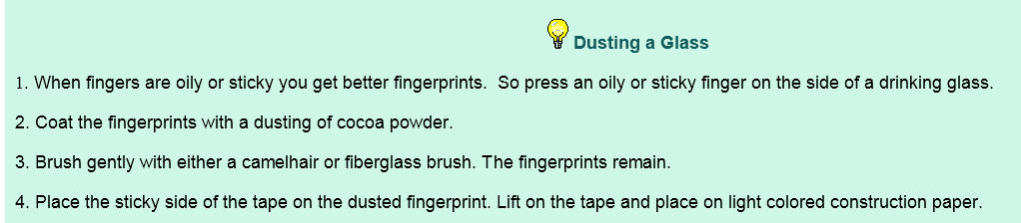
Materials used are:
- Drinking glass
- Cocoa powder
- Brush: camelhair or fiberglass
- Transparent tape

Step 1
Press an oily or sticky finger on the side of a drinking glass.
Step 2
Coat the fingerprints with a dusting of cocoa powder
Step 3
Brush gently with either a camelhair or a fiberglass brush. The fingerprints remain.
Step 4
Place the sticky side of the tape on the dusted fingerprint. Lift the tape and place it on light colored construction paper.

- Method 2: graphite powder (or pencil dust)
See http://www.ehow.com/how_2096229_take-fingerprints.html

Materials used are:
- Pencil
- Knife
- Coin
- Feather of fine brush hair
- Transparent tape

Step 1
Look for objects that can potentially carry fingerprints. Fingerprints leave better impressions on smooth objects. These items hold the best prints: glass, painted surfaces, metal, linoleum, varnished woods and paper.
Step 2
Grind some graphite powder from a pencil. Using a knife, break the lead from a pencil into tiny pieces. Use a coin on a flat surface to grind the pieces into a fine powder.

Step 3
Sprinkle the powder onto your object. Lay the object on a flat table and gently coat the surface of the object with a fine layer of graphite powder.
Step 4
Reveal the fingerprint. Lightly dust the powder off the surface with a feather. The powder will stay attached to the oils from the suspect's skin, and a fingerprint should take shape. Be sure to dust very lightly, or you may dust away the fingerprint.
Step 5
Transfer the fingerprint. Holding a small strip of transparent tape at both ends, place the tape over the fingerprint. Press it down for a moment, then carefully pull the tape up from one end. The fingerprint will transfer onto the tape.
Step 6
Place the tape face down on an index card. Repeat the process for each fingerprint you can find on the object, and place them on the same card.

- Try out both methods to take fingerprints from an object
- Discuss which method you prefer, explain why
- Discuss which other materials might be used.
- Write a manual to take fingerprints form an object inspired by the methods described here and other sources you found.

