1.3 Take your own fingerprints
Fingerprints can be found on objects at a crime scene. These prints have to be matched with the fingerprints from the suspect. In this part, you will take your own fingerprints. Everybody has heard of fingerprints and of course you have seen in television series how these prints were taken. However, you can not always believe things you see on you see on television.
- Discuss in your group what might be a proper method to take fingerprints from a person.
There are different ways to take your fingerprints. For this moment, we start with two methods that are not difficult to do with easily available material. We will do this in a step by step way.

1.3.1 Method 1: pencil dust
- Rub a small dark area with a pencil point on a sheet of white paper.
- Press and rub your right index finger in the pencil-lead dust.
- Place the sticky side of a piece of transparent tape on the dusted finger.
- Take the tape with the fingerprint and tape it to in the box below.
- Repeat this process for the thumb of your right hand.
- If you are not satisfied with one of the fingerprints, use the spare box to take another fingerprint. Be sure to write down which fingerprint this is.
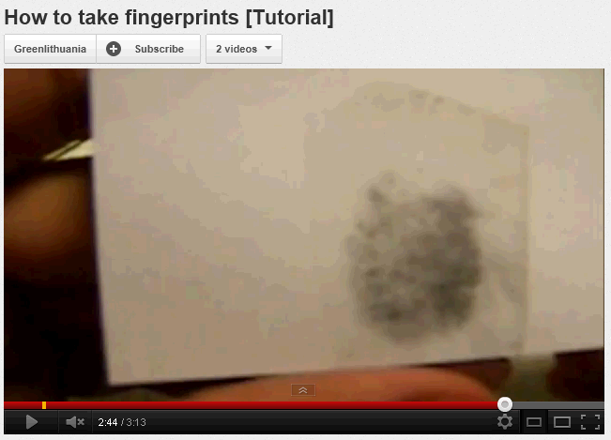
The method above is demonstrated on youtube. You might want to watch it before taking the fingerprints.
http://www.youtube.com/watch?v=to6NYRgM184

Index finger right hand | Thumb right hand | Spare box: index finger right hand / thumb right hand

1.3.2. Method 2: inkpad
For the left hand, we are going to use a stamp pad (inkpad).
- Press your index finger of your left hand to an inkpad.
- Carefully press and roll your finger on a piece of white paper.
- Be careful to protect your clothes and not to slide your finger across the paper.
- If you are satisfied with the result, make a new print of your finger in the box below.
- Repeat this process for the thumb of your left hand.
- If you are not satisfied with one of the fingerprints, use the spare box to take another fingerprint. Be sure to write down which fingerprint this is.
Index finger left hand | Thumb left hand | Spare box: index finger left hand / thumb left hand

- Discuss which method to take fingerprints from a person you prefer.
- Explain what the pro’s and cons are of these two methods.

