3.3 Analyzing the DNA
For each DNA feature the frequency to occur is known. When several features are combined, it is easy to calculate the frequency of this specific combination. In the next table, we see some features with frequencies for inhabitants of the Netherlands.

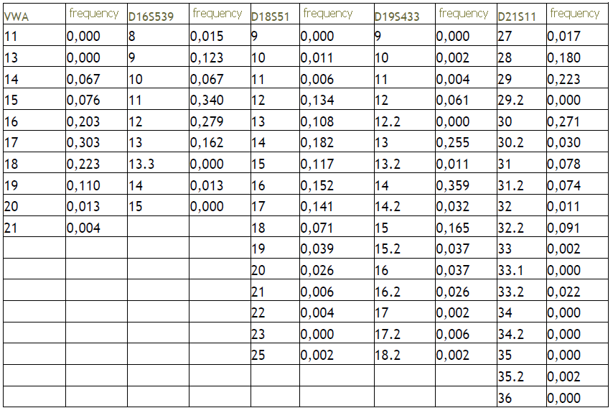

- What is the frequency for feature 19 on locus D18S51?
- What is the sum of all the possibilities for the feature D 16S539?
- What would you expect as an outcome of this calculation?

- A trace found on a crime scene has the following features: VWA 14; D18S51 17 and D21S11 32. Calculate the frequency for this combination.

