  - How can fingerprints be categorized?
In forensic science, a team of scientists does research on a crime scene to find information and evidence about the suspect and the victim. The forensic scientist is not a judge but he or she advices the judge on how likely it is that something has happened. The next lessons, you are going to work as a forensic scientist. You will do research on fingerprints, you will do research on other human properties and you will find out about footsteps. To start with, take a look at the fingerprints.

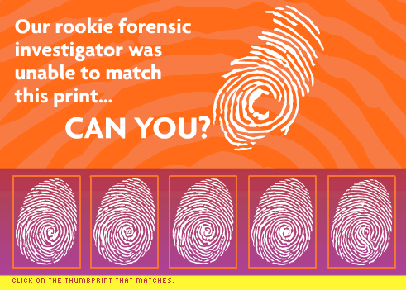

In police files, finger prints are complete but in a crime scene you rarely find a complete finger print. In this game you have to match an incomplete finger print with one of five complete prints from the police files. You can find this fingerprint game here: http://www.trutv.com/shows/forensic_files/games/fingerprint/index.html

- Play this game three times, write down for each trail how many attempts you needed to find a match.
- Write down for each attempt on the basis of which properties you decide that the fingerprint found on the crime scene matches that of one of the suspects.
- How many attempts do you need in total to find the three fingerprints?
- What is the record in your class?
You have used different properties of a fingerprint to match with the filed prints.
- Write down at least three properties of fingerprints that can be used to identify a specific fingerprint (for the specific game you have written down some properties in the second question of this activity).
- Discuss these properties with your fellow students and build a system to categorize fingerprints.
- Compare the categories from your system with information you can find on internet, see for example: http://www.fun-science-project-ideas.com/The-science-of-fingerprints.html

